Special Blades for Skidancing
“O-do-rya-nn-se”
‘Odoryanse’ means, “Shall we dance” in Japanese. I’ve designed the blades myself after 15 years of research and study in Skidancing. You can change your edges cleanly even on one leg both in forward skiing and in backward skiing.

Our blades are much closer to normal skis compare to Gauer’s blades in the structure. It is convex at the center, slightly up to the top and the tail. Designed a bit narrow throughout the blades for changing edges easily. Very light and flexible for elaborate edge work.

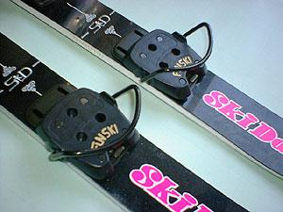
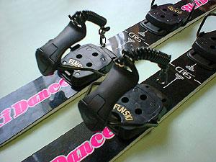

Attached free size bindings  21cm~28cm available  Length 80cm  Waist 6.7cm | 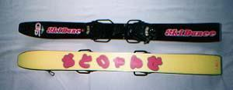 | \10,000 yen for 1set  Including tax and shipment
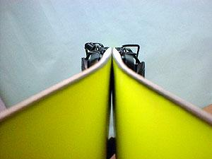
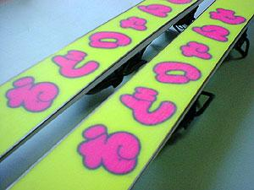

If you want to get them, please return to my web site and see Questions & Applications

